Source Water Protection Grant Program
FY 2016-2017
Grant Application

Thank you for your interest in the Joint Water Commission’s (JWC) Source Water Protection Grant Program. Applications are available on the JWC website at www.jwcwater.org. Hard copies are available upon request from the point of contact provided in this application package.

Grant Program Purpose
The Joint Water Commission’s Source Water Protection Grant Program is intended to support the work of local organizations whose efforts maintain and safeguard the quality of water entering the JWC’s drinking water treatment plant. Successful projects will utilize proactive watershed activities to research, prevent, minimize or mitigate potential water quality contamination.
This grant program is also intended to promote stakeholder partnerships and increase public awareness of drinking water. Awardees are encouraged to leverage funds from multiple sources and use these monies as matching funds for other grant opportunities.

Drinking Water Source Area
A ‘drinking water source’ is the water from rivers, streams, lakes, springs or groundwater that drinking water providers use to supply communities with safe drinking water. Protecting drinking water sources involves taking proactive steps to manage potential sources of contamination and prevent pollutants from reaching, entering, or degrading sources of public drinking water.
Generally, the JWC’s drinking water sources include the Tualatin River upstream of Forest Grove, Gales Creek, Carpenter Creek, Scoggins Creek, Hagg Lake, Wapato Creek, and Barney Reservoir. A map outlining the JWC’s drinking water source area is shown as Figure 1.
The predominant land uses in the JWC’s drinking water source area are forestry and agriculture, with small amounts of rural and urban development. Potential water quality contamination types were identified in the JWC’s 2013 Source Water Assessment and 2014 Source Water Protection Plan (available online at www.jwcwater.org).

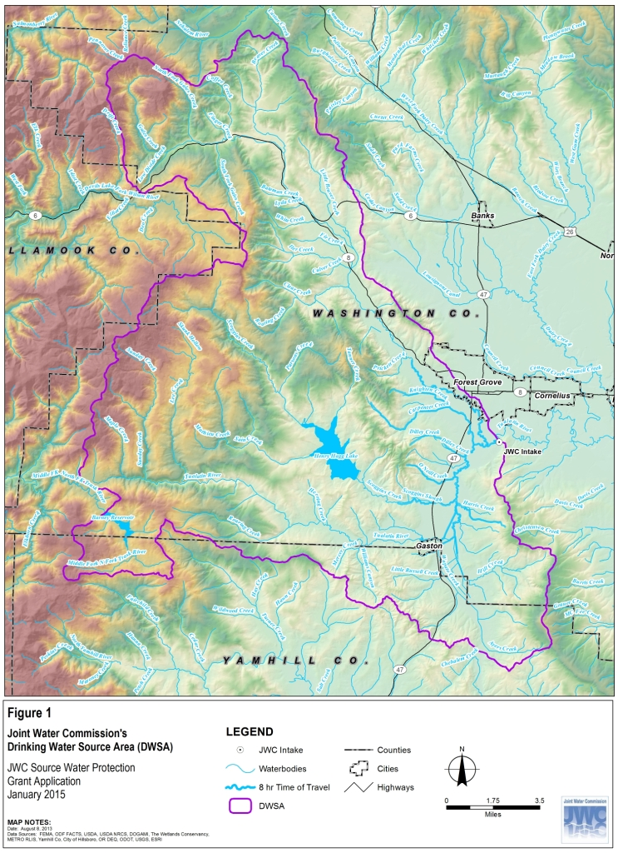
Potential Project Types
For purposes of this grant program, source water protection projects are defined as programs or activities that address drinking water quality concerns. Grant requests may be made for any project or activity that researches, prevents, minimizes, or mitigates potential water quality contamination in the JWC’s drinking water source area. Proposed project budgets may include administrative support. Specific water quality parameters of interest include bacteria, nutrients, carbon, synthetic and volatile organic chemicals, algal blooms and associated taste and odor compounds.
The JWC Source Water Protection Plan has identified potential contamination risks of interest including:
- Agricultural and forestry chemical applications and runoff
- Septic tanks
- Rural and urban development
- Public roads and railroads

Specific locations within the drinking water source area of particular interest include:
- Flood zones
- Within an 8-hour travel time of the JWC’s water treatment plant (shown on Figure 1)
- Unstable and/or vulnerable soils
- Wetlands

The focus and types of proposed projects may include, but is not limited to:
      - Implementation of best management practices (BMPs) to reduce erosion, runoff, or chemical usage
- Wetland or riparian restoration
- Creation of demonstration areas or pilot projects
- Research on water quality
- Development and distribution of public outreach/educational messages on water quality contamination or watershed protection

Eligibility Requirements
Please note that incomplete applications or applicants who do not meet the eligibility requirements will not be considered.
- Applicants must be a tax-exempt 501(c)(3) organization, a state or local agency, or a university.

- The proposed project or activity must be located within or directly impact the JWC’s drinking water source area (see Figure 1).
- Projects and activities required to meet federal, state, or local agency permit or regulatory requirements or contract obligations are not eligible for funding from this grant request.

2015-2016 Grant Funding
The Joint Water Commission has a limited budget for the Source Water Protection Grant Program for fiscal year 2016-2017 (June – July). Average award amounts are expected to range from $5,000-$8,000. Grant funding will be provided as one payment delivered at project award. Upon award, awardee(s) must sign the JWC’s Grant Agreement (attached and provided at www.jwcwater.org).
Funding for the Source Water Protection Grant Program may be modified or suspended during times of economic downturn, when revenue sources for the JWC are reduced, and/or by JWC Commissioners consistent with the adopted budget.
Grant award and program budget recommendations will come from the JWC’s Source Water Protection Technical Advisory Committee and Operations Committee. Applications will be reviewed, scored and ranked according to the criteria listed on the Application Evaluation Form (attached and provided www.jwcwater.org).
If a grant recipient fails to comply with all grant procedures, the organization will not be eligible for award in the next grant cycle.

Grant Process Timeline
Applications available | Monday, April 24, 2017
Completed application package of one (1) electronic copy due by 9:00 a.m. | Monday, May 15, 2017
JWC staff review of applications | Completed by May 19, 2017
Incomplete applications or organizations not meeting the eligibility requirements will not be considered and the applicant will receive a notice via email.
Distribute application packets to the JWC SWP Technical Advisory Committee for review | May 19, 2017
JWC SWP Technical Advisory Committee deliberation and award recommendations | Completed by June 16, 2017
Approval of award recommendations by the JWC Operations Committee  Grant award notification letters mailed to applicants | Completed by June 22, 2017  Completed by June 23, 2017
Grant recipients announced at the JWC Board meeting | July 14, 2017
First six (6) month progress report due to the JWC (additional progress reports required every six (6) months until project completion)  Final project report and presentation to JWC Board | October 31, 2017  Within 6 months of project completion

Project Reporting Requirements
A short project update is required every six (6) months until the project is complete. If the awarded funds make up a small portion of a long-term project, six (6) month progress reports are only needed until grant awarded funds have been spent. Then when the entire project is complete, a final project report will be required. An email reminder and form will be sent to grant recipients 1-2 months prior to the due date.
Upon project completion a brief report and presentation to the JWC Board is required.
If a grant recipient fails to comply with all grant procedures, including filing six (6) month progress reports, the organization will not be eligible for award in the next grant cycle.

Application Delivery and Deadline
Completed applications must be received electronically no later than the date and time listed on the Grant Process Timeline. Applications received after the deadline will not be accepted. Submit the application as one (1) pdf document by email to the contact person listed below.

Application Checklist
For the application to be considered, please ensure the following items are included:
- Applicant Fact Sheet
- Certification
- Questionnaire
- Budget Worksheet

Point of Contact
Kristel Fesler City of Hillsboro – Water Department
Kristel.Fesler@hillsboro-oregon.gov Joint Water Commission Managing Agency
(503) 615-6735 Hillsboro Civic Center – 3rd Floor
150 E Main St
Hillsboro, OR 97123

Applicant Fact Sheet

Organization Name:
Address:
Mailing Address (if different from above):

Contact Person:
Title:
Phone: | Fax:
Email:

Certification
Applicants applying for funds through this program are obligated to spend the funds in the manner described in their application. All funds not specifically used for the purposes described in this application must be returned to the Joint Water Commission. Failure to meet the objectives outlined in the application may result in future disqualification from applying for and receiving Joint Water Commission Source Water Protection Grant Program funds.
I hereby certify that all the facts, figures and representations made in this application, including all attachments, are true and correct.
I agree to perform the project or program as specified within this application.
I certify that, to the best of my knowledge, the information in this application is correct, that the applicant organization approves of this application, and that I am duly authorized to sign this application on behalf of the applicant organization.

Name of Organization
Type of Organization (i.e., non-profit, special district, community college)
Signature of Authorizing Official | Date
Name and Title of Authorizing Official
Questionnaire
- Describe the proposed activity, project or program. Is the proposed project part of a larger project? Where will the project be located? How will the requested funds be spent? A budget table is provided under Grant Request Budget Worksheet. Please be specific (1,000 words max).

- Describe the intended outcome of the project. How will awarding funds to this project benefit Joint Water Commission source water? (500 words max)

- How will you evaluate the success of the project or program? (500 words max) Please note if awarded funds the applicant will be required to submit a progress report every six months until project completion (see Project Reporting Requirements).

- Is the proposed project still feasible if awarded partial funding?

Budget Worksheet
Project Information
Project Title
Funding Amount Requested | $
Project Start and End Dates

Project Expenses
(Provide detail in Questionnaire)
 | Amount
Administration | $
Labor | $
Equipment/Materials | $
Other | $
Total Expenses | $

Project Funding Sources
(Please separate funding that has been confirmed from anticipated funding. Please provide the equivalent dollar amount for in-kind services)
 | Confirmed Funding | Anticipated Funding
JWC Source Water Protection Grant |  | $
Applicant | $ | $
Other Government | $ | $
External Sources (private business sponsors, donations, events, fundraising, etc.) | $ | $
Subtotal | $ | $
Total Confirmed and Anticipated Funding | $

